# Exercise 4: Arrange-Act-Assert (AAA) Pattern, Test Fixtures, Setup and Teardown Methods in JUnit

You need to organize your tests using the Arrange-Act-Assert (AAA) pattern and use setup and teardown methods.

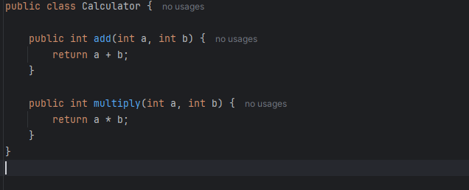

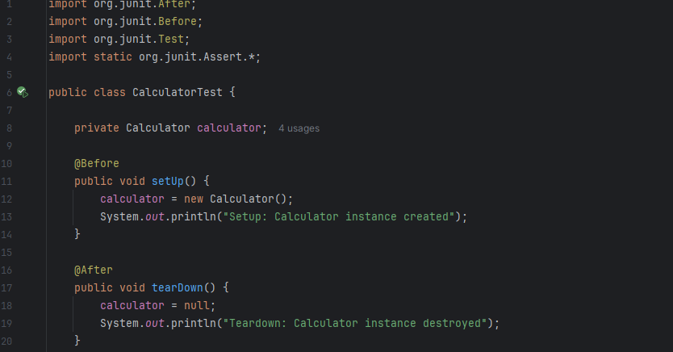

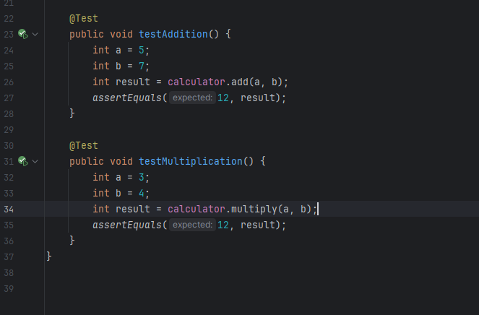

Output:

